Harkerearth question
Read from STDIN, Write to STDOUT | Basics of Input/Output & Basic Programming Practice Problems
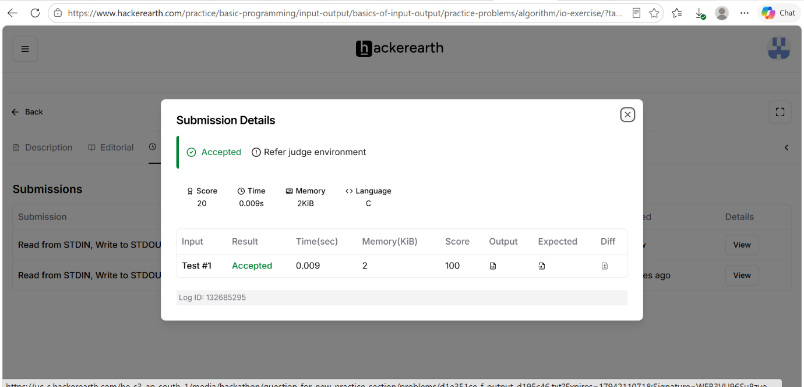

Code
#include <stdio.h>
int main() {
int N;
char S[16];
scanf("%d", &N);
scanf("%s", S);
printf("%d\n", N * 2);
printf("%s\n", S);
return 0;
}

